# Organic Chemistry Reaction Type Summary (Part 1)

# Hydrocarbons

# Alkane

1. Combustion
   * Complete Combustion

If the oxygen supply is plentiful, the combustion products will be carbon dioxide and water.



* + Incomplete Combustion

When the oxygen supply is limited, carbon monoxide can be formed instead of carbon dioxide.



1. Substitution

Alkanes can react with halogens such as chlorine and bromine in ultraviolet light. In these reactions, a carbon-hydrogen bond is broken and replaced by a carbon-halogen bond.

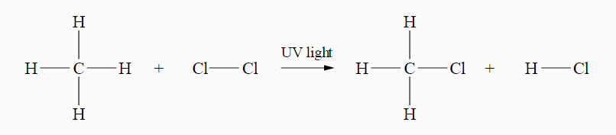

* + Alkanes are not very reactive, and UV light is required for the reaction.
  + Two products are formed

# Alkene

1. **Combustion (See alkane)**
2. **Addition Reactions**

Alkenes are generally more reactive compounds than alkanes. The reactions of alkenes usually involve the addition of a small molecule to the double bond of the alkene.

During addition reactions:

* a single product is formed
* the double carbon-carbon bond is converted to a single bond
* an unsaturated compound becomes saturated
* the atoms of the small molecule added to the alkene are 'added across the double bond' so that one atom or group from the molecule forms a bond with each carbon atom in the double bond.

Examples:

* **The reaction of alkenes with hydrogen (hydrogenation)**

Alkenes will react with hydrogen in the presence of a catalyst such as nickel to form alkanes.

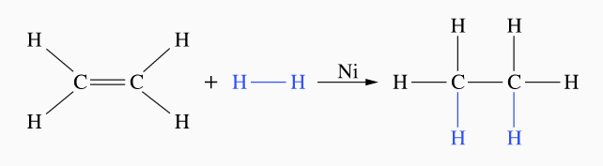

* **The reaction of alkenes with halogens or hydrogen halides**

Alkenes react with halogens or hydrogen halides to form haloalkanes

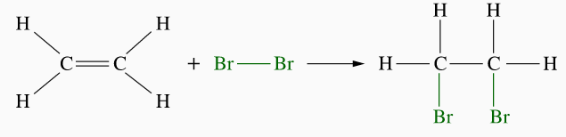

**Markovnikov's rule**

If a hydrogen halide (e.g., HCl) is added to an unsymmetrical alkene, the hydrogen atom is added to the carbon with the greater number of hydrogen atoms, and the halogen to the carbon with the least number of hydrogen atoms.

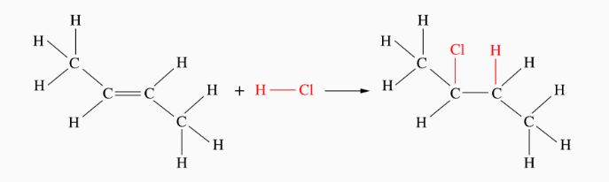

* **Reactions of alkenes with water (hydrolysis)**

Ethanol can be produced by adding ethene and water using a catalyst to increase the reaction rate.

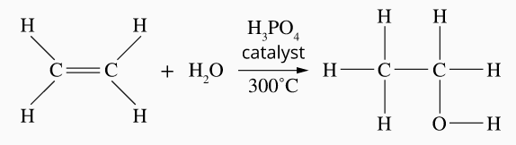

# Benzene

Benzene does not readily undergo addition reactions, as no double bonds exist. However, they will undergo substitution reactions in the presence of a catalyst to speed up the reaction.

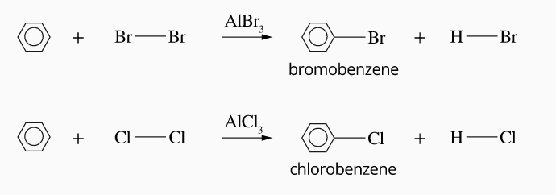

# Organic Chemistry Reaction Type Summary (Part 2)

# Alcohols

1. **Combustion of alcohol**

Alcohols burn readily in the air to form carbon dioxide and water as products.



1. **Other oxidation reactions of alcohols**

Alcohols can also be oxidised by inorganic oxidising agents such as acidic potassium dichromate solutions, K2Cr2O7, and potassium permanganate, KMnO4. The products of these oxidation reactions depend on the type of alcohol involved.

* Primary alcohols first oxidise to form aldehydes and then (under high-temperature conditions) carboxylic acids.

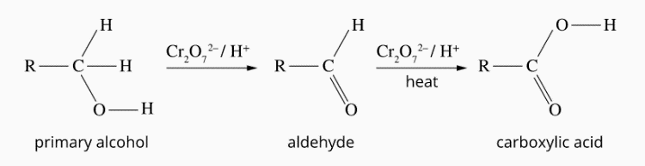

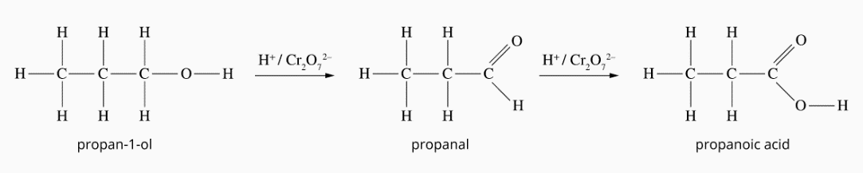

* Secondary alcohols oxidise to form ketones.

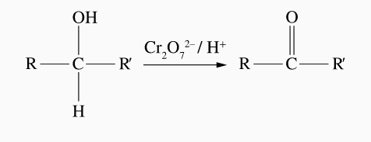

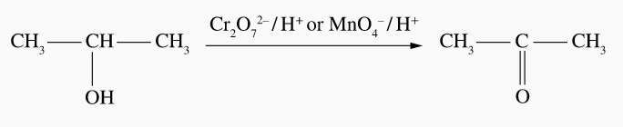



* Tertiary alcohols are resistant to oxidation by these chemicals.

# Carboxylic acids

1. **Ionisation in water**

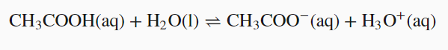Carboxylic acids such as methanoic and ethanoic acids are weak, so they only ionise to a small extent in water.

1. **Reactions of carboxylic acids with metals and their compounds**

Carboxylic acids can undergo reactions typical of other acids, such as inorganic acids. Some examples are given below.

* Reaction with metal oxides and hydroxides to give metal salts and water



* Reaction with metal carbonates and hydrogen carbonates to give salt, water and carbon dioxide.



* Reaction with reactive metals, such as sodium and magnesium, to give a salt and hydrogen gas



1. **Reactions of carboxylic acids with alcohols (esterification reactions)**

A condensation reaction between carboxylic acid and alcohol makes esters.

